of the lead conversion process

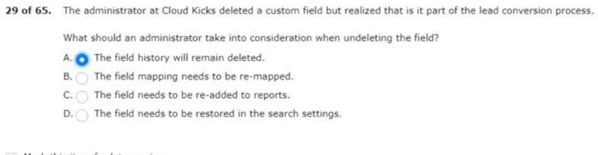

- to add repeating tasks in salesforce.
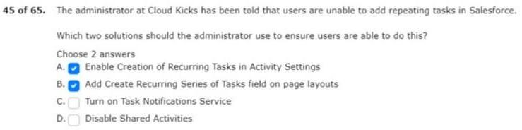

- are speaking with high-profile customers.
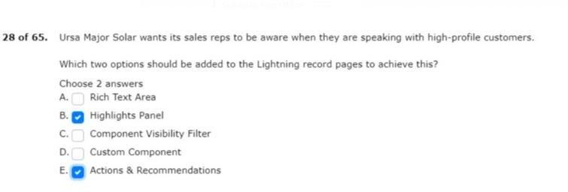

in its org to display contact association

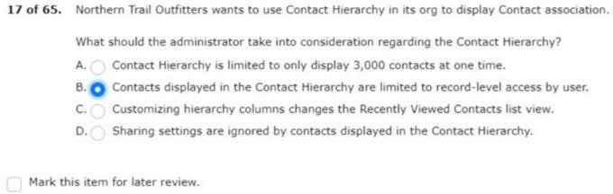

- prices on the products they purchase.
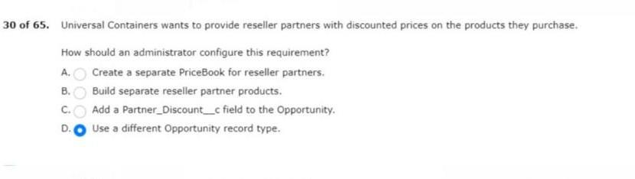
- be part of the opportunity upon lead conversion.
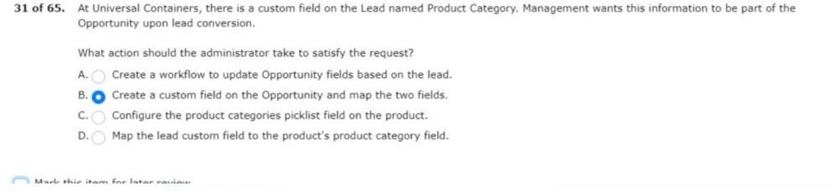
- cases that reference the new product.
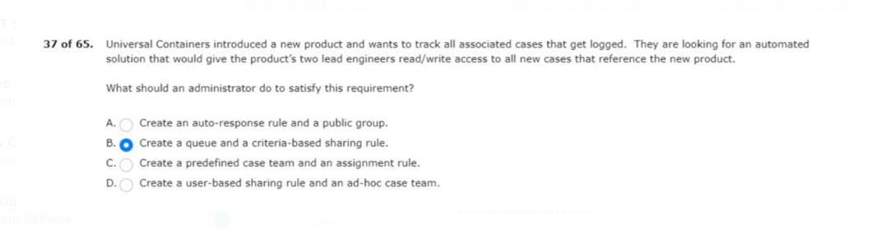

is creating a validation rule

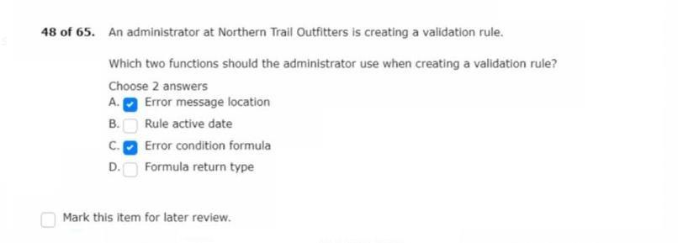

- posting status is updated to interviewing.
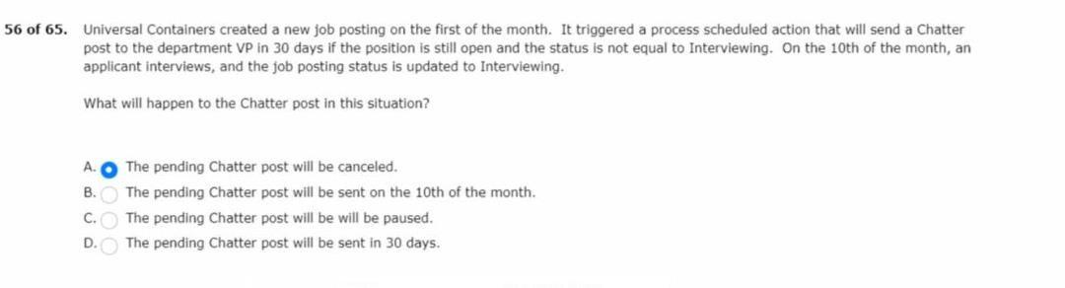
- new employees at northern trail outfitters.
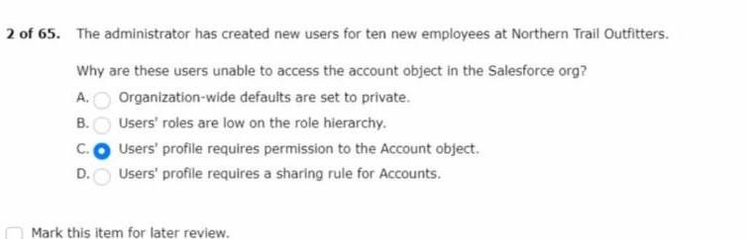
on before leaving the company

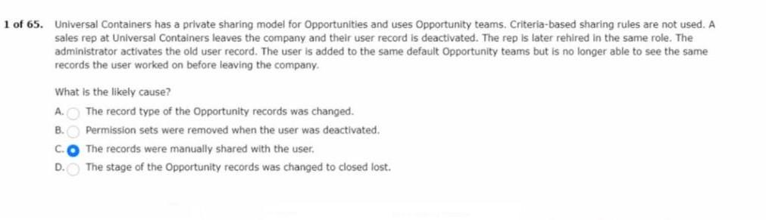

- is doing an audit of the system’s security.
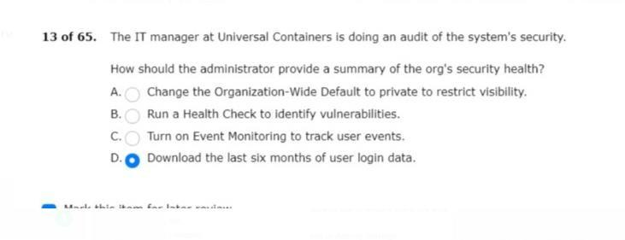

- and has been locked out of the organization.
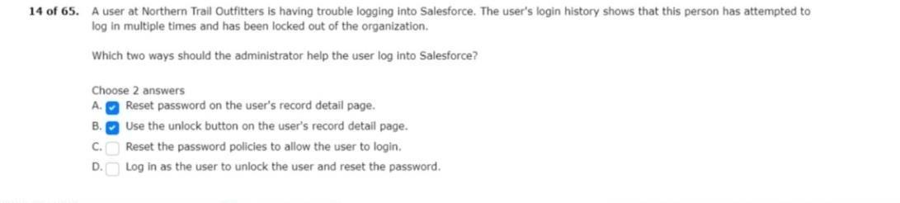

for their salesforce accounts

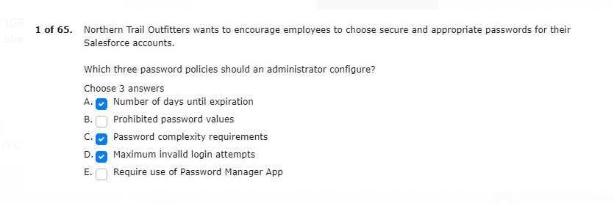

- expected to close in the next 90 days.
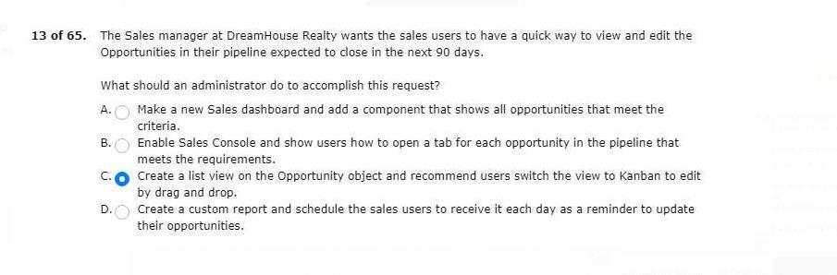
- period for the user’s bookmarks to be updated.
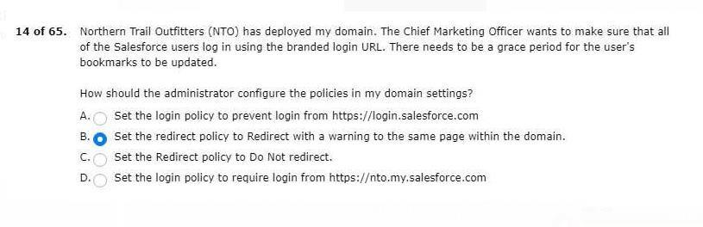

should be able to view and edit all reports

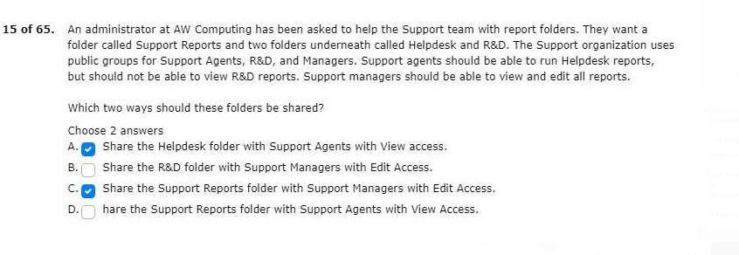

18. unable to add a new user in salesforce.
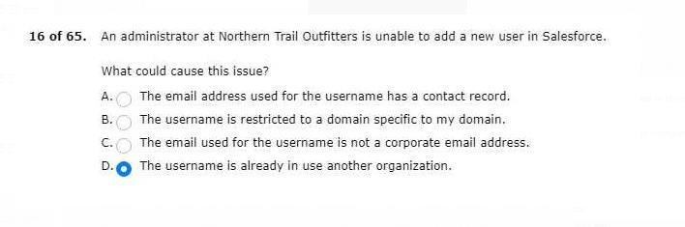
the stage setup flow
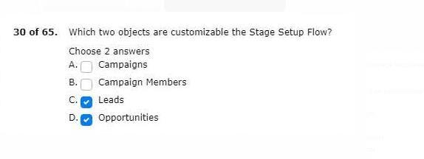

20. of the opportunity upon lead conversion.
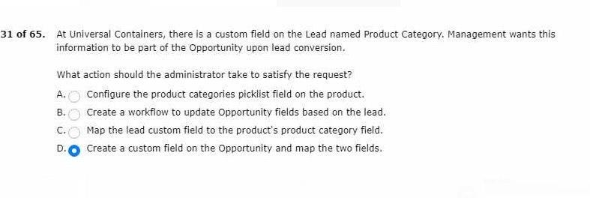

22. automatically re-assigned to the next tier queue.
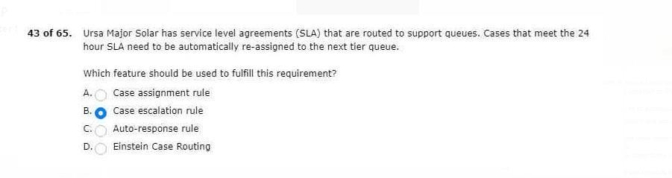
than the fields needed by the service team
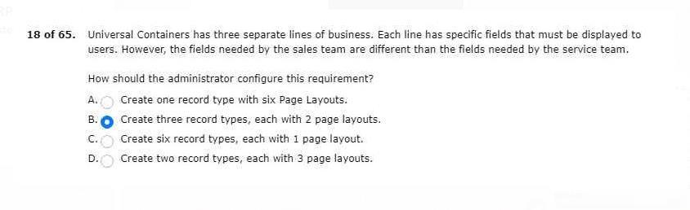

- is having trouble logging in to salesforce.
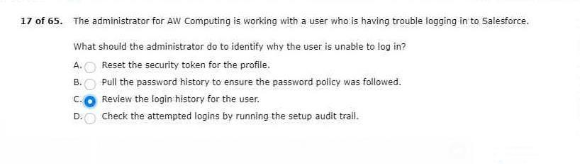
- records to custom object from a new API
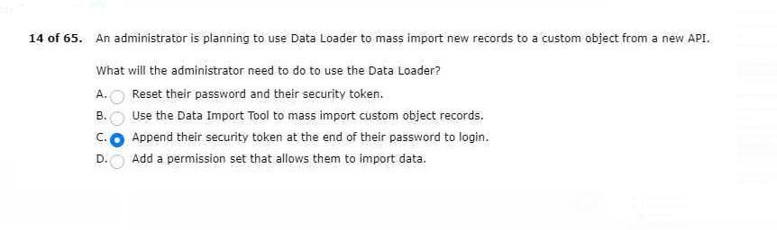

- would normally be found under this tab.
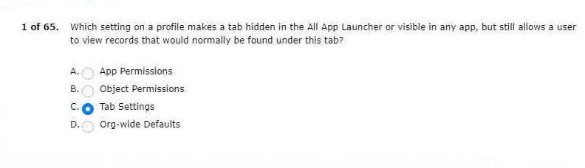

to see owner status and contact
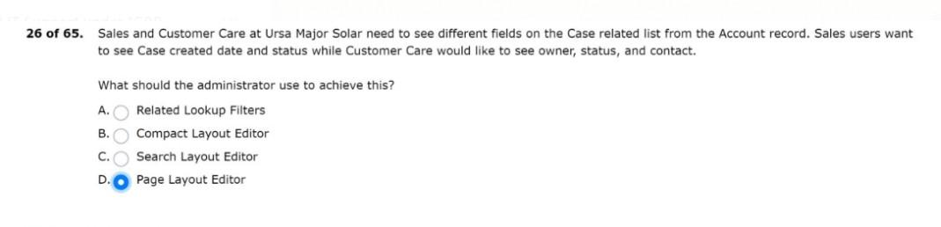

28.is creating a validation rule

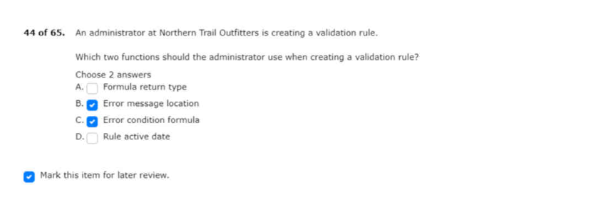
29.
30.

